2014SMART_Logo_360px (2)

**Transportation Division**

**GENERAL COMMITTEE GO-513**

*Dale Barnett*  **CSXT/L&N-NC&ST.L & CRR** *Brian Killough*

*GENERAL CHAIRMAN* 3560 Cardinal Point Drive ASSISTANT CHAIRMAN

SUITE 103

*Jeremy King*  Jacksonville, FL 32257 *Ronnie Head*

VICE CHAIRMAN 904.733.1250 SECRETARY

904.733.1252 (FAX)

December 11, 2015

Michael Wanner, HDO

CSXT - Labor Relations

6735 South Point Drive, South, J-455

Jacksonville, Florida 32216

**RE: Prior Right Protected Trainmen at Erwin/Dante and Former L&N, CRR and NC&ST.L**

Sir,

I am officially providing notification of an ongoing penalty claim for every day that CSX willfully and blatantly disregard and violate our Crew Consist agreements on behalf of J.L. Bennett 609880, A.W. Foster 609908 and E.W. Dickenson 609907 for 8 hours for every day that they have not been provided a position on an reserve pool position as required per the Crew Consist, and any other prior right protected employees affected on or after this date.

**Claim of CSXT Trainman:** J.L. Bennett (609880)

**Date and Time of Occurrence:** JAD week of 1010-15 – until

**Train Symbol, Pool Code or Job Number:** Various EBS ZTBR Bulletins

**On and Off Duty Time:** Not Applicable

**Supply Point:** Z134

**Location of Occurrence:** Erwin, TN

**Name and Title of Person Giving Instructions:** CMC/LR/Division

**Article or Articles involved:** Crew Consist Agreements

**Claim of CSXT Trainman: A.W. Foster** (609908)

**Date and Time of Occurrence:** JAD week of 10-10-15 – 11-20-15

**Train Symbol, Pool Code or Job Number:** Various EBS ZTBR Bulletins

**On and Off Duty Time:** Not Applicable

**Supply Point:** Z134

**Location of Occurrence:** Erwin, TN

**Name and Title of Person Giving Instructions:** CMC/LR/Division

**Article or Articles involved:** Crew Consist agreements

**Claim of CSXT Trainman:** E.W. Dickenson (609907)

**Date and Time of Occurrence:** JAD week of 12-12-15 – until

**Train Symbol, Pool Code or Job Number:** Various EBS ZTBR Bulletins

**On and Off Duty Time:** Not Applicable

**Supply Point:** Z35

**Location of Occurrence:** Dante, VA

**Name and Title of Person Giving Instructions:** CMC/LR/Division

**Claim Being Made:**

Claim is hereby made on behalf of CSXT Trainmen JL Bennett, AW Foster and EW Dickenson and any other prior right protected trainmen affected in the same manner and violation from the date of this letter until resolved and seeking a penalty payment of eight (8) hours a day at reserve pool conductor’s rate of pay for the JAD week beginning 10-10-15, and that they be made whole for all benefits and credits for qualifying purposes (RRB, vacation, etc.) lost when CMC’s EBS failed to properly award these trainmen an assignment on a reserve pool position for the supply point location as defined by the extra board jurisdiction.

The Carrier has refused to honor the Crew Consist agreements to establish reserve pools for the supply point and have either displaced and furloughed these trainmen or forced them to another supply point location within their seniority district

We have a number of trainmen that have either prior right protected CRR seniority, prior right protected L&N seniority, CRR 1980 protected seniority and/or 1985 L&N protected seniority, and any other applicable protected trainmen, that work within the Erwin/Dante/Kingsport Terminals that have been affected by CSX reducing or eliminating the work force in these locations in the Carrier’s actions as of October 15, 2015.

Our office has advised that we have protected prior rights trainmen and protected trainmen that simply cannot be furloughed nor forced to another location outside of their prior rights and protected seniority home district. The CSRA Article 25 affords such protection as does the L&N Crew Consist Agreements.

***CSRA***

***Section 7 Prior Rights Seniority***

***A. Trainmen possessing prior rights on the road and former yard seniority rosters will continue to possess relative prior rights to positions advertised at their home terminal (sub-district).***

***B. Prior rights employees will not be required to protect assignments or vacancies on former districts on which they do not hold prior rights.***

***Article 7, Section A, Q&A #5 of Crew Consist Codification Agreement 4-86-92***

**Q-5**

**In the event the junior protected employee is displaced and *there are no positions at that location* his seniority would permit him to claim, how may such employee be placed?**

**A-5**

**He may be placed as follows:**

1. **Added to the extra board protecting service from which displaced or,**
2. **Placed in the reserve pool by creation of an additional reserve pool slot and he will be subject to immediate recall during the advertisement period or,**
3. **Employees with a seniority date later than January 31, 1986 may be forced to another extra board jurisdiction to displace a junior employee or claim an open must fill position. If more than one such location exists, the employee be offered a choice of locations and will select within 24 hours.**

The UTU L&N 1985 National Agreement, Article 52 (SBD T-006-86), Crew Consist Agreement, Article 1,states, as follows;

“***nor will a protected employee be furloughed or remain on furlough as long as a reduced crew is operating in his seniority district***,”.

Article 2 of this same agreement states:

***“(a) All employees holding seniority dates on road brakeman and/or helper seniority rosters on the effective date of this agreement shall be known and designated as protected employees***”.

SBD Agreement T-007-86, Memorandum Agreement between the SBD and the UTU (Former L&N, NC&ST.L. and CRR) outlines the three consolidated seniority districts on these former properties. Article 1, (d) and (e) state:

***(d) “Employees holding seniority on each of the separate seniority districts on the effective date of the consolidation will establish priority rights to work on such former seniority districts, and shall be referred as to as prior rights employees”.***

***(e) “Employees who presently hold prior rights on seniority districts previously consolidated will continue to hold such rights.***

I have advised of the following senior prior right protected trainmen being mishandled at Erwin and Dante due the Carrier’s election to reduce/eliminate the assignments and work force at Erwin.

JL Bennett 609880 is an Erwin yard prior rights protected trainman that has never been outside the yard. If the yard is eliminated then a reserve pool will have to be established for him and AW Foster 609908. JA Woodward is another senior protected prior rights trainman at Erwin that should have been provided a reserve pool position for Erwin Yard from the time he was furloughed at this supply point location for the yard until the date he retired. EW Dickenson 609907 has worked at Dante or Erwin his entire career and has been at Dante for the last 10 years or son working and as of December 12 2015 CSX CMC and the Huntington Division Manager have elected to cut off an extra board position at this supply point location and he will be displaced. CSX should be establishing a reserve pool at this location with a position added for Mr. Dickenson but instead are basically forcing him to an assignment at Kingsport under the guise of not providing sufficient bids in his district under the EBS Article 11.

The Carrier violated the articles of agreement found in the Letter of Understanding dated March 9, 2012, when they forced Mr.Dickenson from his position at Dante, Virginia on the AP DA Sub-District to Kingsport, Tennessee and the AP-KP Sub-District. That agreement governs times *“when Trainmen are needed for an unfilled vacancy and manpower is not available at that location”* (here the AP KP Sub-District at Nashville, Tennessee). Mr. Dickenson had made no bids for any AP KP Sub-District assignment because he was not qualified to work any of those assignments, nor did he want to work any of those assignments (see agreement’s Step 1). Mr. Dickenson had made no indication he was willing to *“protect a manpower shortage at other locations”* by contacting CMC to advise them of his willingness to do so (see agreements Step 2). Lastly, Mr. Dickenson was not *“the junior furloughed Trainman in an EBS Zone”* and was not subject to being forced (see agreement’s Step 3), and any such forcing would *“only be applied when Trainmen are not furloughed at the location forced to.”* At the time, there were numerous Trainmen furloughed from the AP KP Sub-District.

The Carrier violated CSRA Article 11, Section 1, Paragraph A when they forced Mr. Dickenson from one supply point (Z35) to another supply point (Z94). Mr. Dickenson had submitted *“preferences for positions for which qualified”* as required by the first sentence of the cited article of agreement. All of those positions were on the AP DA Sub-District. Mr. Dickenson was not qualified to work any position on the AP KP Sub-District and it would not be proper for him to bid on any position that he was not qualified to work. The Carrier repeated stance that Mr. Dickenson had failed to submit sufficient bids by not bidding on assignments he was not qualified to work, which resulted in his being forced, is simply not true.

The Carrier violated the 1994 L&N, CRR, NC&ST.L and Monon Crew Consist agreement that consolidated the following applicable Crew Consist agreements: T-006, T-159-88, T-019-89, 4-86-92 and SBD-049-86. CSX did not allow Mr. Dickenson a spot on a reserve pool for the supply point location at Dante, which still has two mine run pool positions and 1 guaranteed extra board(GEB) position. Mr. Dickenson was displaced and a surplus trainman at this location and should have either been placed as a brakeman on the assignment of his choice, a spot on the GEB or provided a reserve pool position.

The added excerpt below clearly defines how Mr. Dickenson should be handled.

1994 Consolidated Crew Consist agreement, Article 9, Brakemen Board, D:

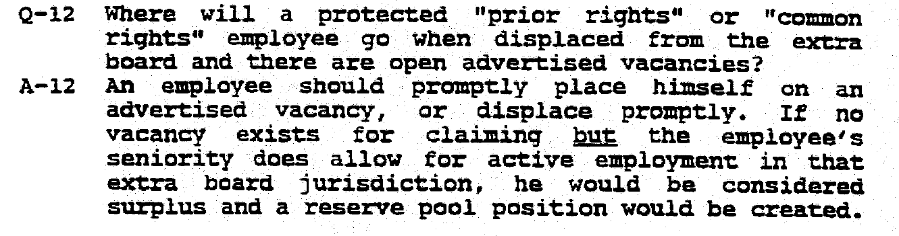

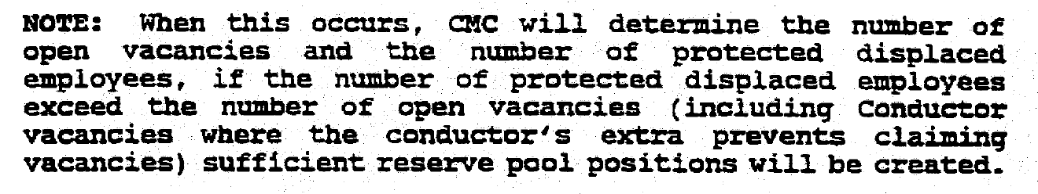

The same protective language of the Crew Consist agreement, which is clear, precise and unambiguous, would also apply for Mr. Foster and Mr. Bennett who were displaced from the Erwin yard supply point location, which had a GEB to protect yard vacancies and numerous yard assignments up until October 15 2015 when CSX decided in one swift move to eliminate every yard assignment and the GEB in action. This was not a situation where work and jobs attrited down but rather the Carrier elected to take this action. But it cannot negate the protection offered to these prior right protected through bargaining where sound and reasonable minds crafted specific language and included Q&As to address any misunderstanding of the intent of the agreements being provided.

The organization would once again provided the following excerpt from the 1994 Codified crew Consist Agreement that is specific and unambiguous in the handling of a displaced protected trainmen at his supply point location;

***Article 7, Section A, Q&A #5 of Crew Consist Codification Agreement 4-86-92***

**Q-5**

**In the event the junior protected employee is displaced and *there are no positions at that location* his seniority would permit him to claim, how may such employee be placed?**

**A-5**

**He may be placed as follows:**

1. **Added to the extra board protecting service from which displaced or,**
2. **Placed in the reserve pool by creation of an additional reserve pool slot and he will be subject to immediate recall during the advertisement period or,**
3. **Employees with a seniority date later than January 31, 1986 may be forced to another extra board jurisdiction to displace a junior employee or claim an open must fill position. If more than one such location exists, the employee be offered a choice of locations and will select within 24 hours.**

As clearly stated in the Crew Consist Agreement language stated above, there is no confusion and there is no other possible alternative for CSX to even consider. The displaced protected trainmen must be provided either the provisions in Step 1 or 2, period. The Carrier has no right to request or require these trainmen exercise seniority to another sub district within their seniority district nor is the Carrier allowed to force these protected trainmen to another location by either attempting to claim they have provided insufficient bids or recalling them from the point of furlough to be recalled to another location. CSRA Article 12, Furlough, does not provide such handling nor a position for CSX to even consider such action.

It has been obvious that CSX understands some of the dynamics of the agreements as Mr. Bennett and Mr. Foster were furloughed on October 15 2015 at Erwin yard and were not forced by EBS to another location or even to the remaining road assignments or GEB that remained at Erwin for an additional few weeks after the shutdown of operations from this location for road and yard work. Erwin is still a designated home terminal and supply point and further evidenced by the fact that CSX provided the Organization with a Notice of ID service running between Kingsport and Bostic and going through Erwin. The Carrier would not need such an ID Notice if Erwin was not a designated home terminal.

The Organization has provided CSX Labor Relations letters dated October 19 2015 and on November 3 2015 to clearly define our position based on the totality of the agreement language. I would remind you per the excerpt below of what has been stated in both letters thus far that CSX continues to snub and disregard.

*As advised by our letter on October 19, 2015, our office requested the establishment of a reserve pool at Erwin, since the all the yard assignments had been eliminated and the Carrier had frozen the EBS bid process on October 14, 2015 for the Job Adjustment Date, JAD, for October 17, 2015, covering the assignments in the Erwin seniority district, for that week ending on October 23, 2015. JL Bennett was placed in furlough status by CSX Crew Management Center, CMC, on October 14, 2015. Per the Codified Crew Consist, signed between the parties on September 19, 1994, under Article 5, it clearly states that protected employees prior to February 1, 1986 cannot be furloughed, period.*

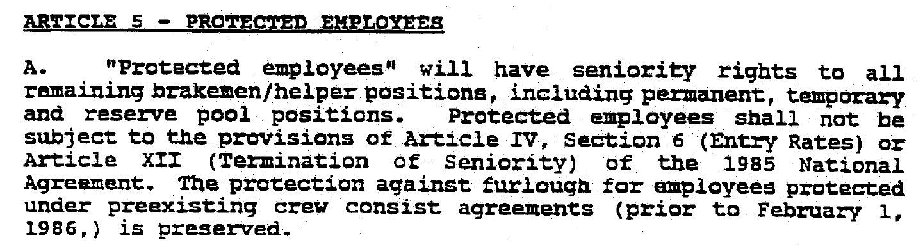

Nothing could be more clear or conceivable to a person of reasonable mind. The Carrier’s response by a 3 page letter dated November 19, 2015 states that Mr. Bennett was recalled to Erwin but that would be impossible since no yard jobs exist at Erwin since October 15 2015. CMC informed him that he was being recalled for Kingsport and his recall letter states such. Your letter also claims that these prior right protected employees should claim positions available at other locations within their home district but failed to provide any specific agreement language that trumps the specific provisions of the Crew consist that the Organization has provided. Your position that requires these prior right protected trainmen to fill vacancies at other supply point locations within their home district is flawed because the agreement language is specific in stating “location” and does not state “district”. PLB 5031 did address the exact same issue and the arbitrator ruled in that case in the affirmative for the Organization. The Carrier now contends that award applied to a different property and some different language existed in the B&O crew consist but actually the nature of that the difference in the language does not apply to the question before the arbitrator then. Nor should it be any different now as the language of the agreement is precise. The fact that the Carrier will hold up a PLB award that was in the affirmative to their position to all CSX properties and other Organizations yet disavow any awards answered in the affirmative to a specific Organization or property as not applying anywhere else. The hypocrisy of such standards is truly sad. Further, the carrier tries to dance around the issue of a reserve pool being required at Erwin by stating that there must be the coexistence of an extra board with a reserve pool yet it was the carrier that elected to eliminate the jobs and the GEB at Erwin but that does allow the Carrier to forgo the requirements of the protection provided under the Crew Consist. Many past precedents have established that the Carrier had honored the crew consist agreements and set up reserve pools. If this had not been the intent of the agreements, then the Carrier could have simply eliminated GEBs everywhere and required prior right protected trainmen to cover vacancies in other locations. That has never been the handling. Interesting that the Carrier takes one position on Erwin and mentions the coexistence of a reserve pool and a GEB then take another position at Dante to displace Mr. Dickenson and force him to another location, and yet Dante has an existing GEB and jobs where the agreement and PLB 5031 would clearly stand for the establishment of a reserve pool for that location of jurisdiction.

The carrier has failed to provide Crew consist language that supports their position while the Organization has clearly shown the exact intent and specific language of the agreement that applies.

I request this matter be added to our expedited party pay arbitration since it is apparent the Carrier does not intent to honor the Crew consist agreements. I will provide the question for this matter to your office to be provided in our Attachment A list.

Given the seriousness of this matter, please respond immediately in writing. Furthermore, and because of the importance of this issue, I would expect an immediate meeting regarding this matter since the Act places an affirmative duty on the parties to ‘make and maintain agreements”.

Sincerely,

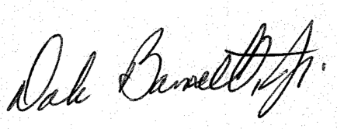

Dale Barnett

General Chairman – GO-513

CC: Michael Wanner, CSXT HDO Labor Relations

John Previsich, President, SMART-TD

Jeremy Ferguson, AVP, SMART-TD